Website Planning Document___________________________________________________

The Mountain Spoke

Author: J.J Hugh

Site Purpose__________________________________________________________________

This site will be utilized as a retail store promotion experience in Bozeman, Montana which specializes in bicycles, bicycle parts, repair services and tour options. It will provide sufficient information for the audience to understand and know what products, services, and layout the physical location will provide.

Target Audience______________________________________________________________

The audience will be the bicycle enthusiasts in the region and for those touring the area who are serious about the sport.

Site Map______________________________________________________________________

The home page will provide an animated preview to the page and will also include a navigation bar, contact information, events, sales, services and the ability to register for the events. The services link with provide access to all services offered in a data table format. Links including pictures, details, videos, and other resources used will be located in the footer.

Color Scheme________________________________________________________________

The color will be a combination of 5 colors, please see the picture below. (see figure 1)

Website Layout include all pages except contact page which will have contact information for the store and then map. (See figures 2 – 6)

Typography__________________________________________________________________

Title & Footer: font-family: 'Rubik', sans-serif;

Header: font-family: 'Bree Serif', serif;

Main Body: font-family: 'Questrial', sans-serif;

Wire-Frame Sketches__________________________________________________________

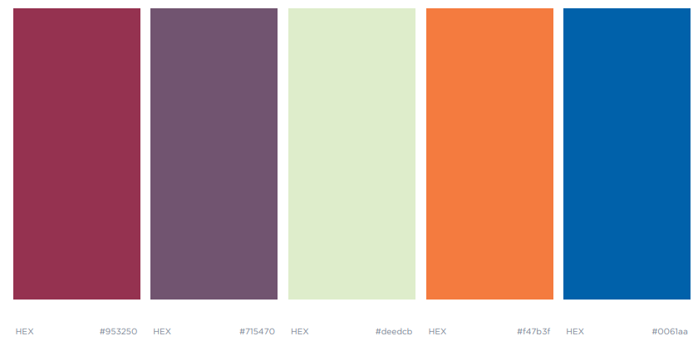

Figure 1

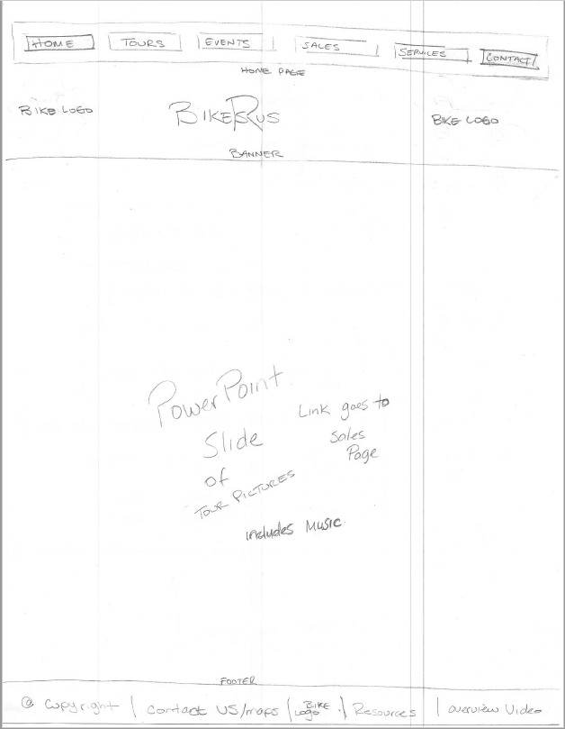 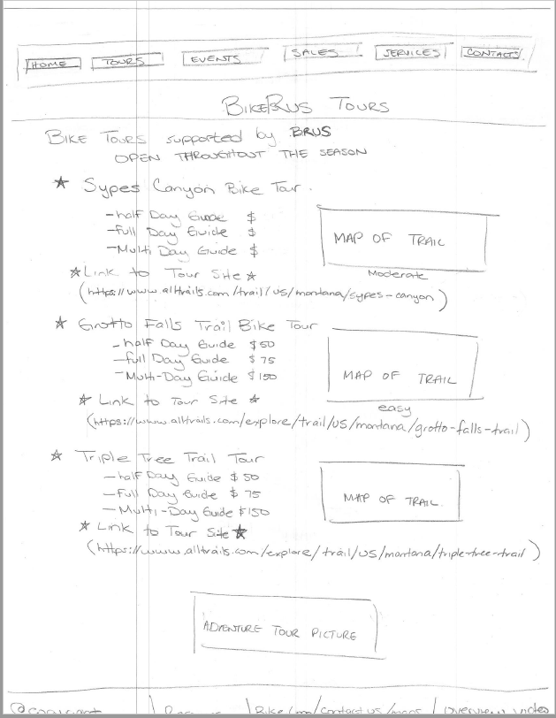

Figure 2 Figure 3

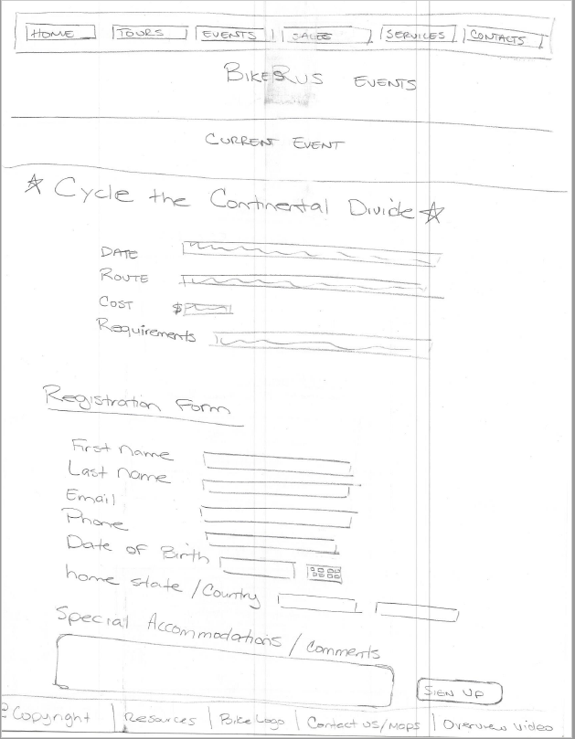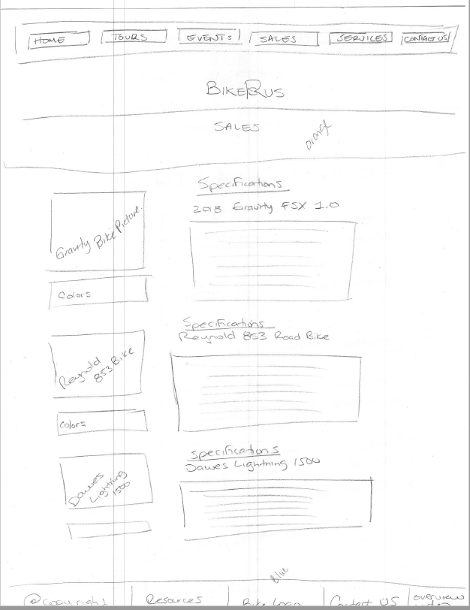

Figure 4 Figure 5

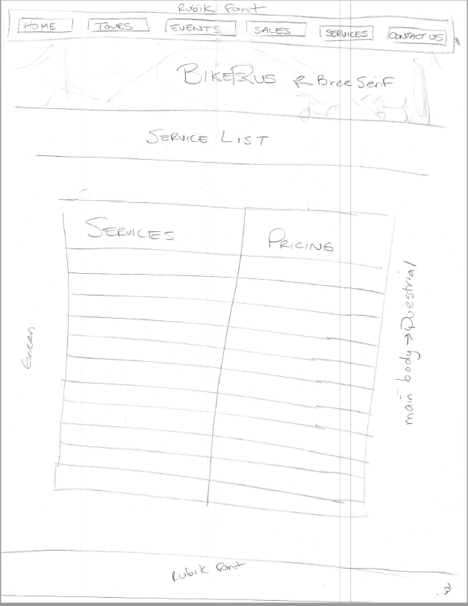

Figure 6